**1.Custom Objects:**

Created **Custom Objects** to support our use case:

* **Doctor** → Stores doctor-specific data (specialization, availability, license info).
* **Patient**→ Holds patient details (age, gender, medical history).
* **Appointment** → Connects patients with doctors and stores consultation details.
* **Prescription** → Stores prescriptions, reports, and treatment history.

Doctor Object:

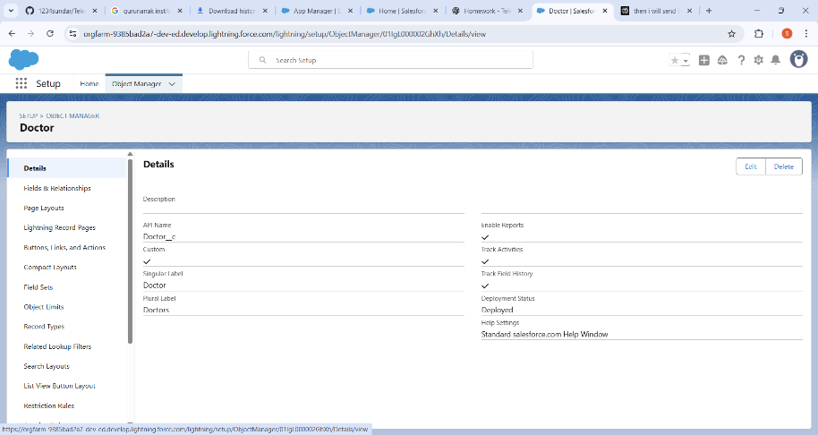

Patient Object:

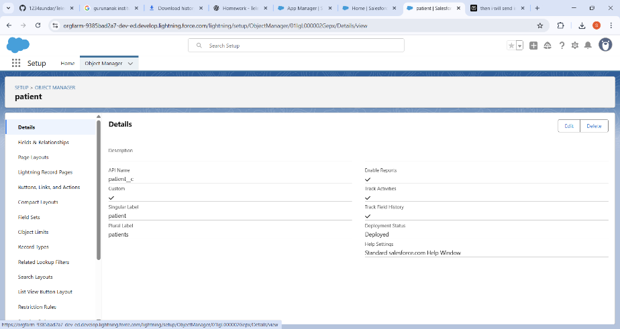

TeleAppointment Object:

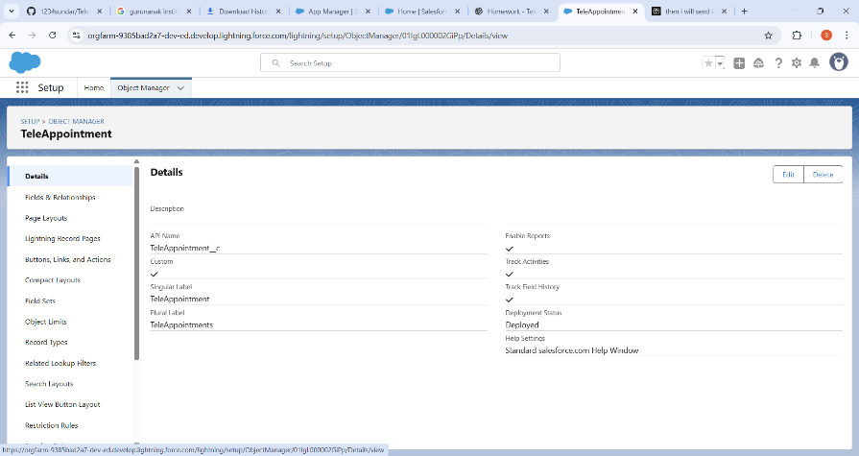

Prescription Object:

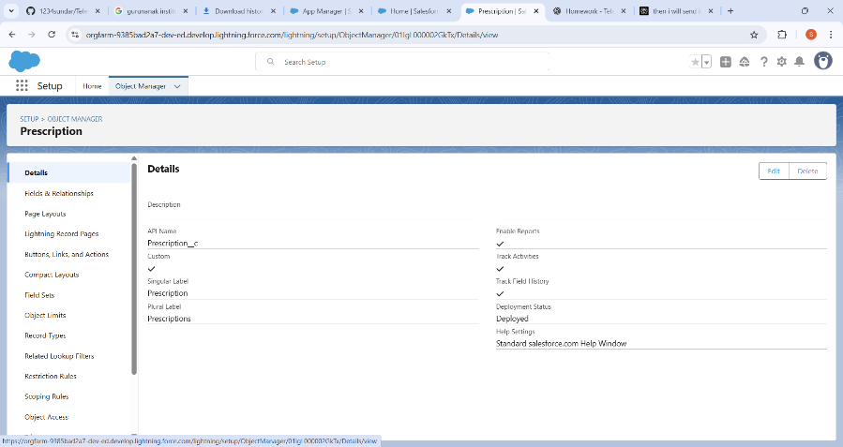

**2.Fields:**

For each custom object, created fields to store critical information:

* **Doctor**→ Specialization, Consultation Fee, Experience, Availability (Picklist).
* **Patient** → Age, Gender, Contact Number, Health Condition (Text/Number/Picklist).
* **Appointment**→ Appointment Date/Time, Mode of Consultation (Virtual/Physical), Status (Scheduled/Completed/Cancelled).
* **MedicalRecord** → Diagnosis, Prescription (Rich Text), Report Upload (File).

Fields for the Doctor Object are:

|  |  |
| --- | --- |
|  |  |
|  |  |
|  |  |

Fields for the Patient Object are:

|  |  |
| --- | --- |
|  |  |
|  |  |
|  |  |

Fields for the TeleAppointment Object are:

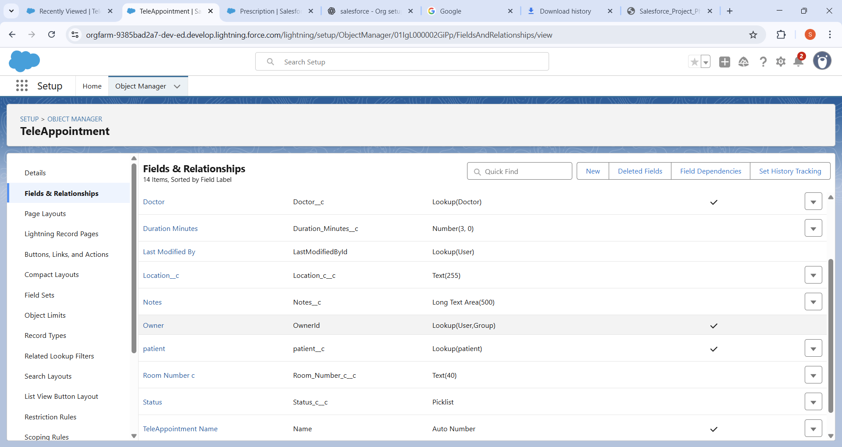

Like wise several fields are created for the TeleAppointment Object.

Fields for the Prescription Object are:

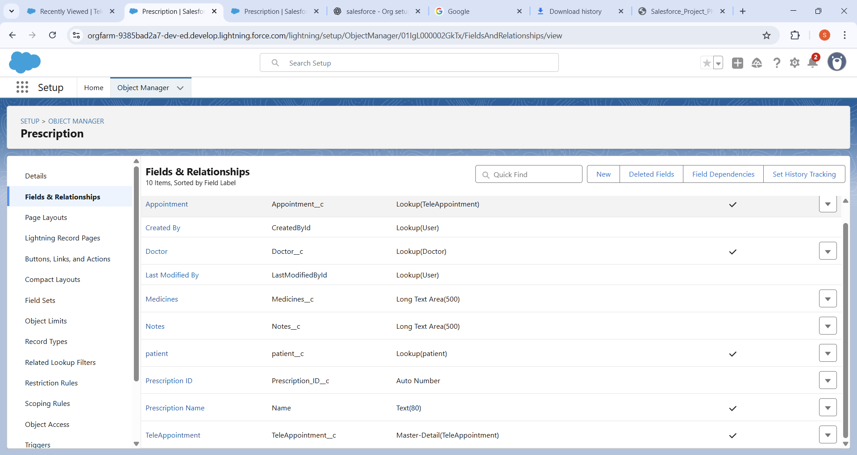

**3.Create the page Layouts:**

Page layouts were configured for each object to make the interface intuitive and user-friendly. Compact layouts were designed to highlight the most important information for quick access, allowing users to see key details without opening the full record.

1. Tele appointment in- person

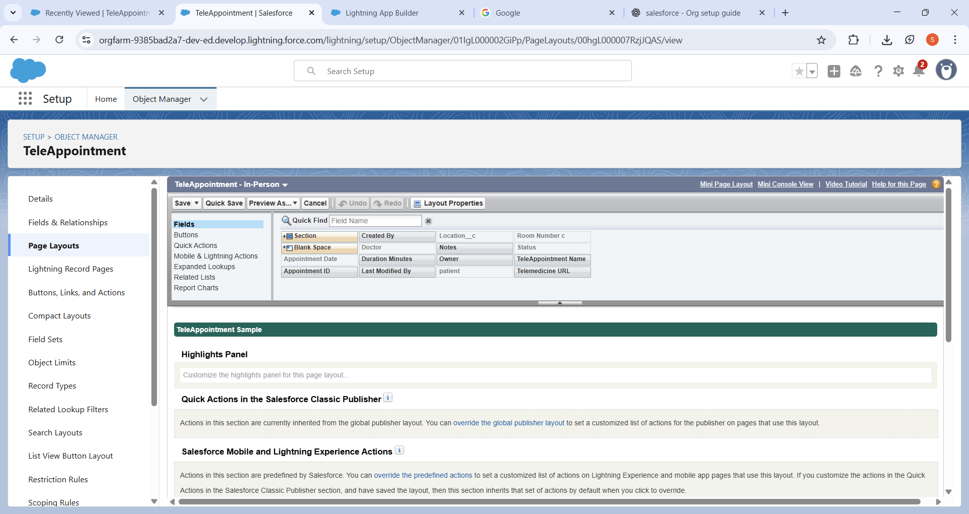

1. Tele appointment Online:

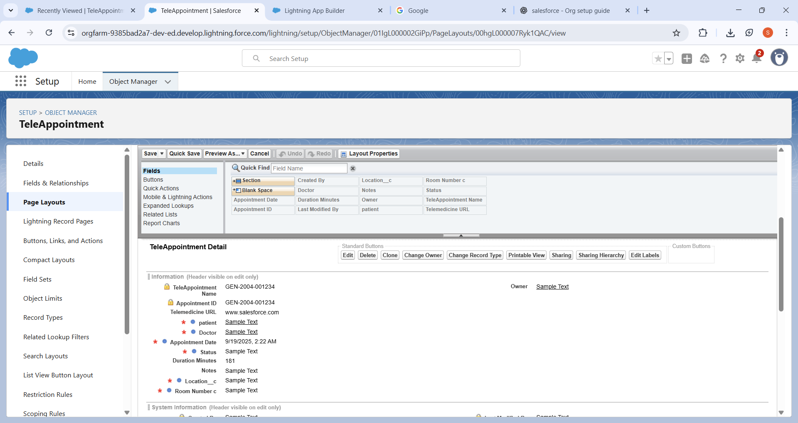

**4. Create Record type:**

Go to Setup → Object Manager → Select Object → Record Types → New.

Enter the record type name and description.

Select a profile or multiple profiles that willhave access to this record type**.**

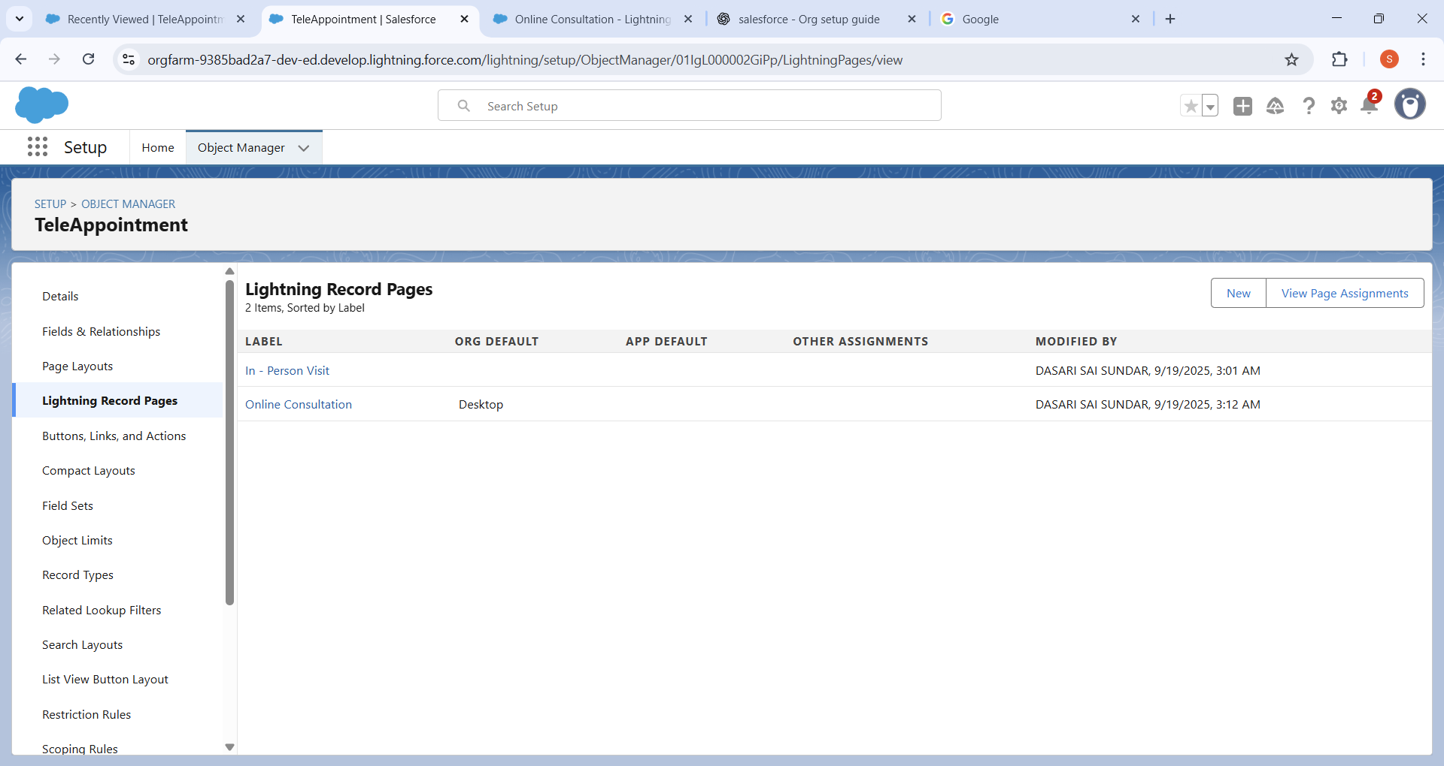

**5. Compact Layout of the Project:**

1. Patient Compact Layout:

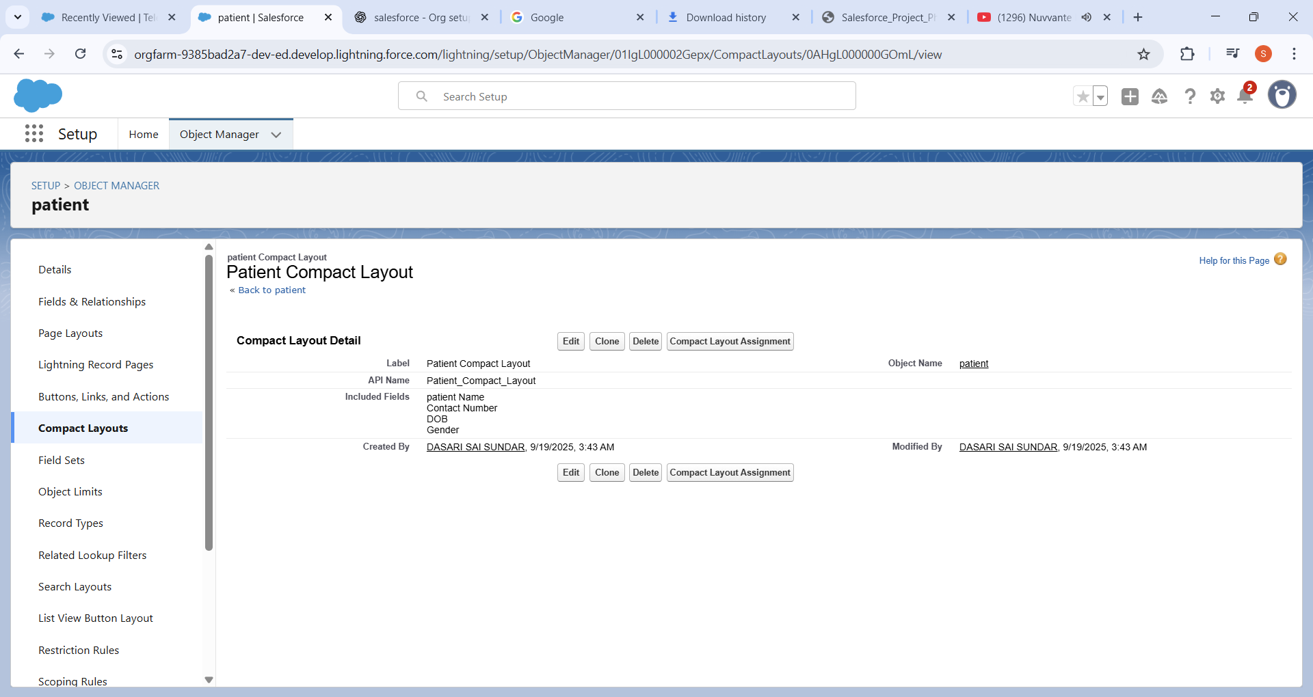

1. Prescription Compact Layout:

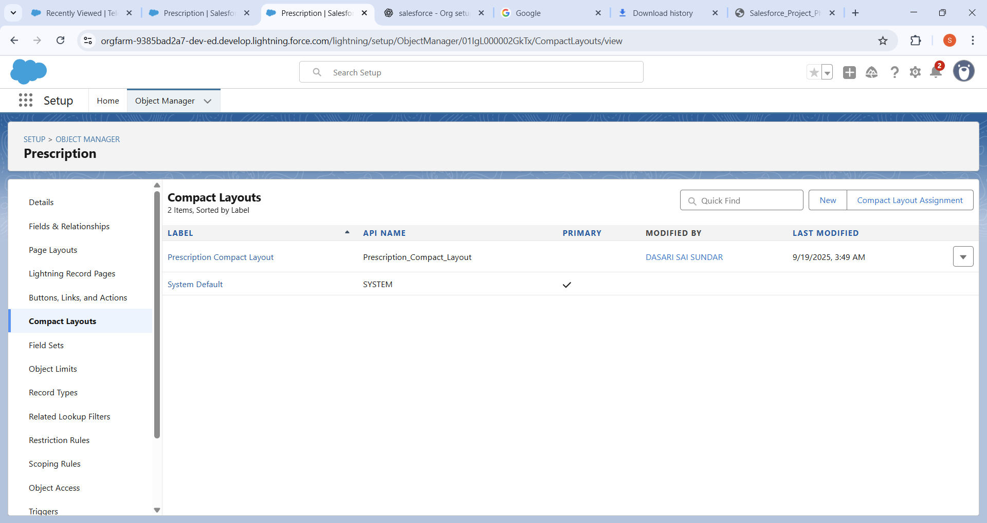

1. Doctor Compact Layout:

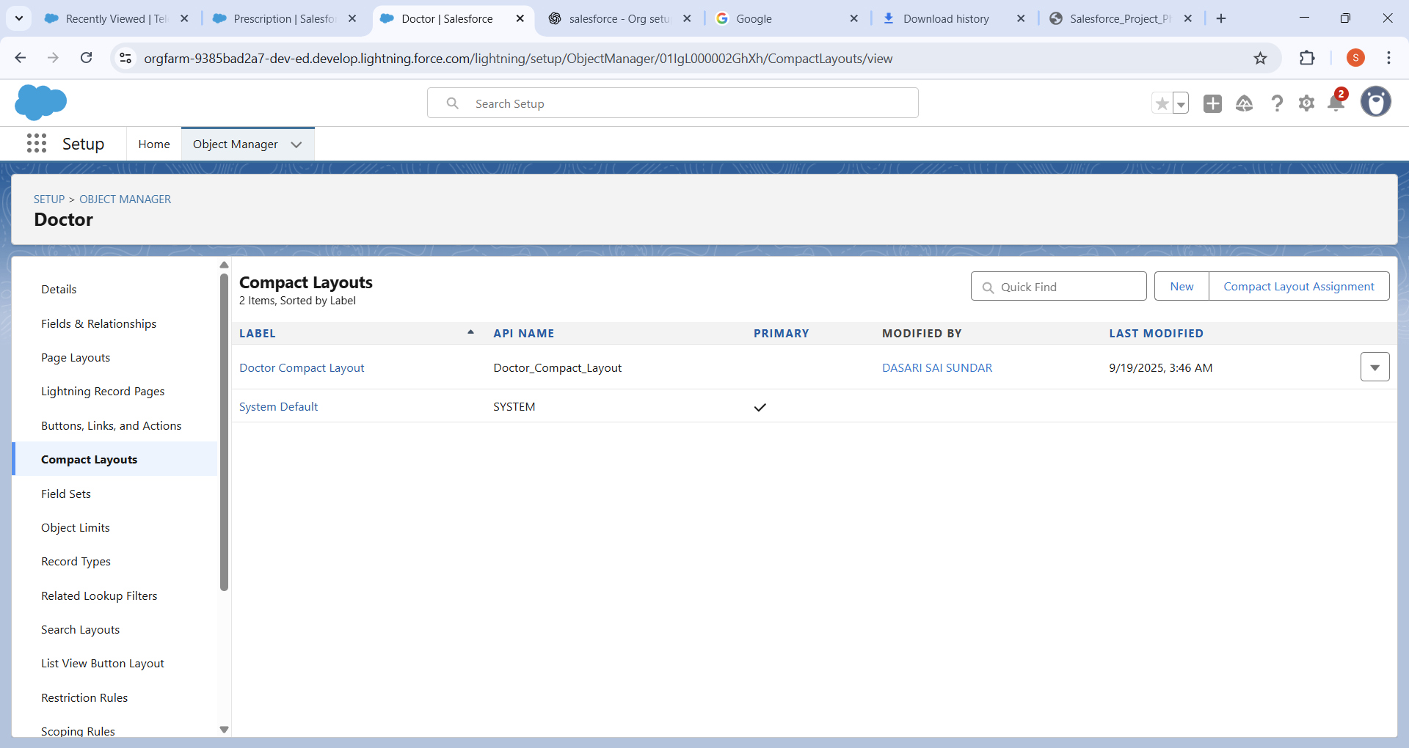

1. TeleAppointment Compact Layout:

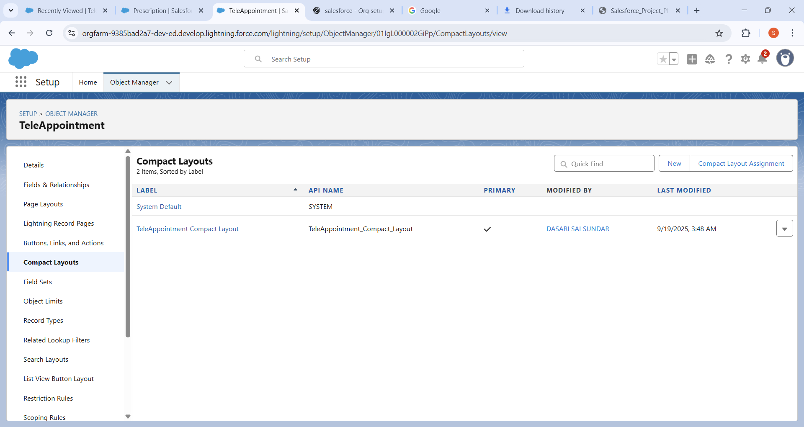

We designed Compact Layouts to highlight the most important details at the top of the record page:

* Doctor → Name, Specialization, Availability.
* Patient → Name, Age, Gender, Health Condition.
* Appointment → Appointment Date, Time, Status.

**6.Schema Builder:**

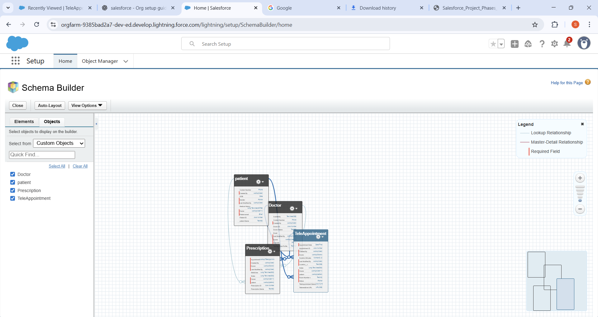

We used **Schema Builder** to visualize the entire data model. Mapped the relationships between Doctor, Patient, Appointment, and Medical Record .Ensured correct lookup and master-detail dependencies. Adjusted field placements for clarity.

**7.Relationships:**

1. The TeleAppointment Lookup relation with the Patient Object

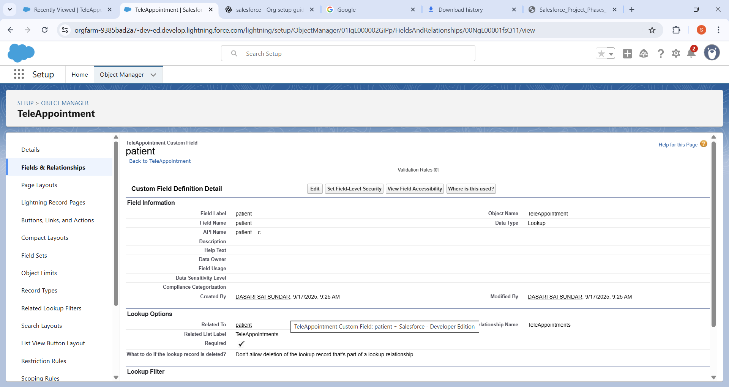

1. Lookup relation between the TeleAppointment to the Doctor.

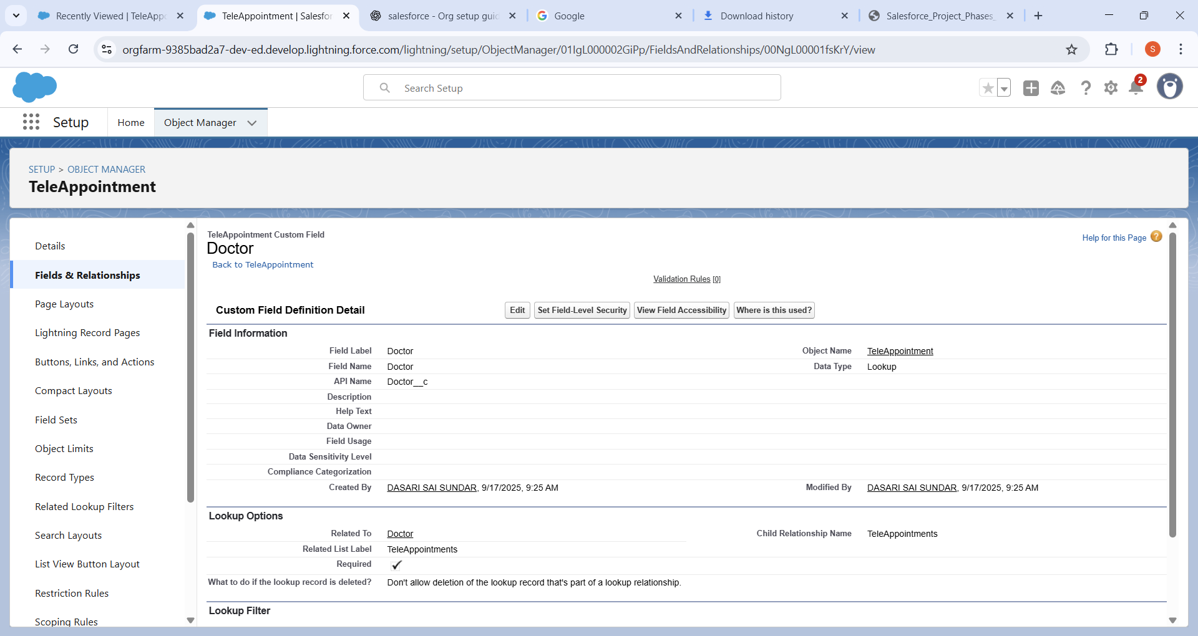

1. Master Detail Relation between the Prescription to the Teleappointment.

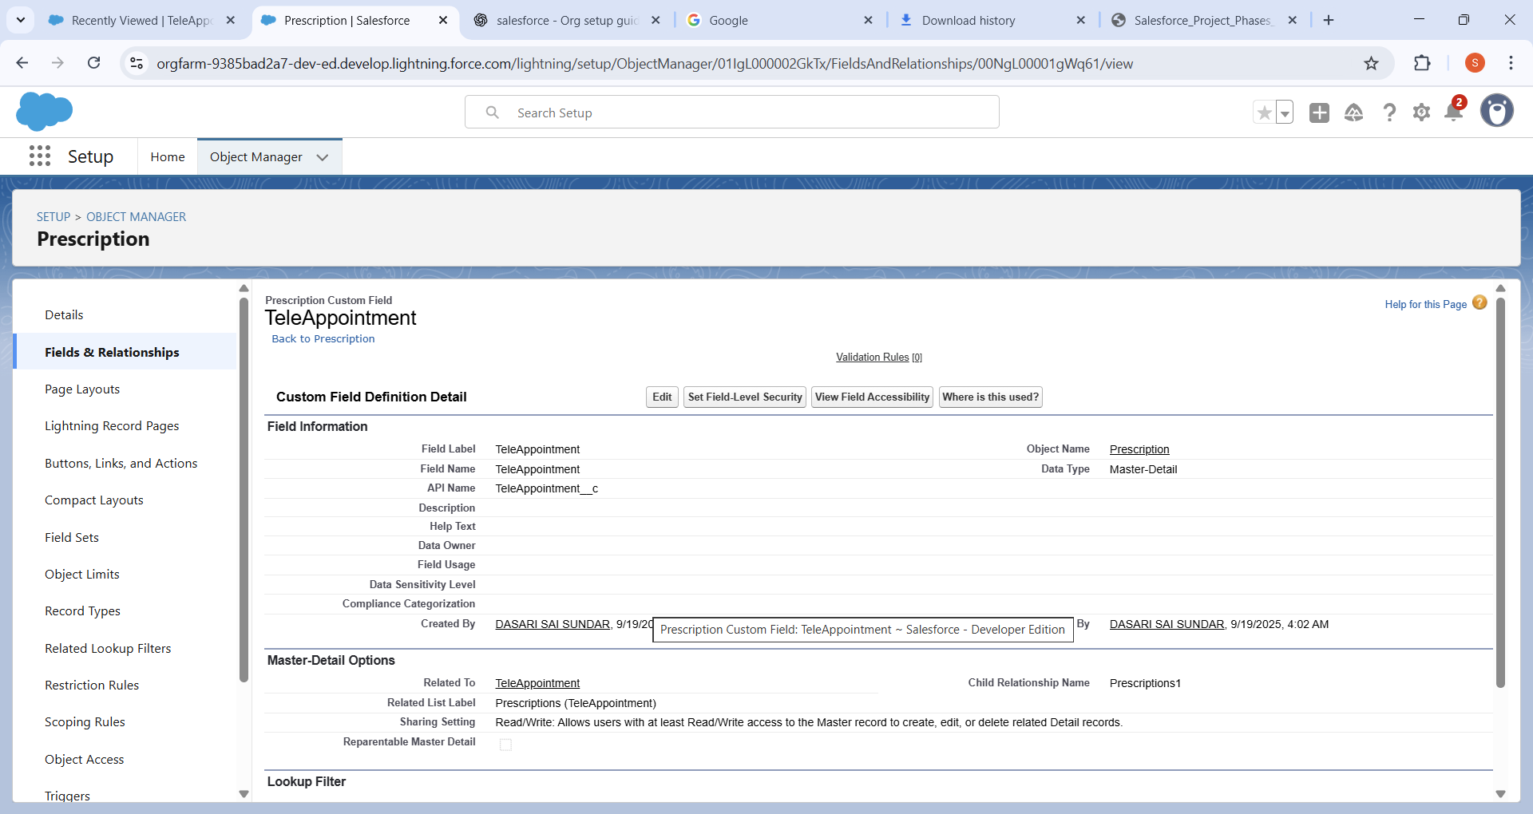

**8. Deployment of the file in the Git hub using the vscode:**

All Phase 3 metadata, including objects, fields, record types, layouts, and relationships, have been deployed to the Salesforce org.Documentation phase to is uploaded to the github repository successfully.

